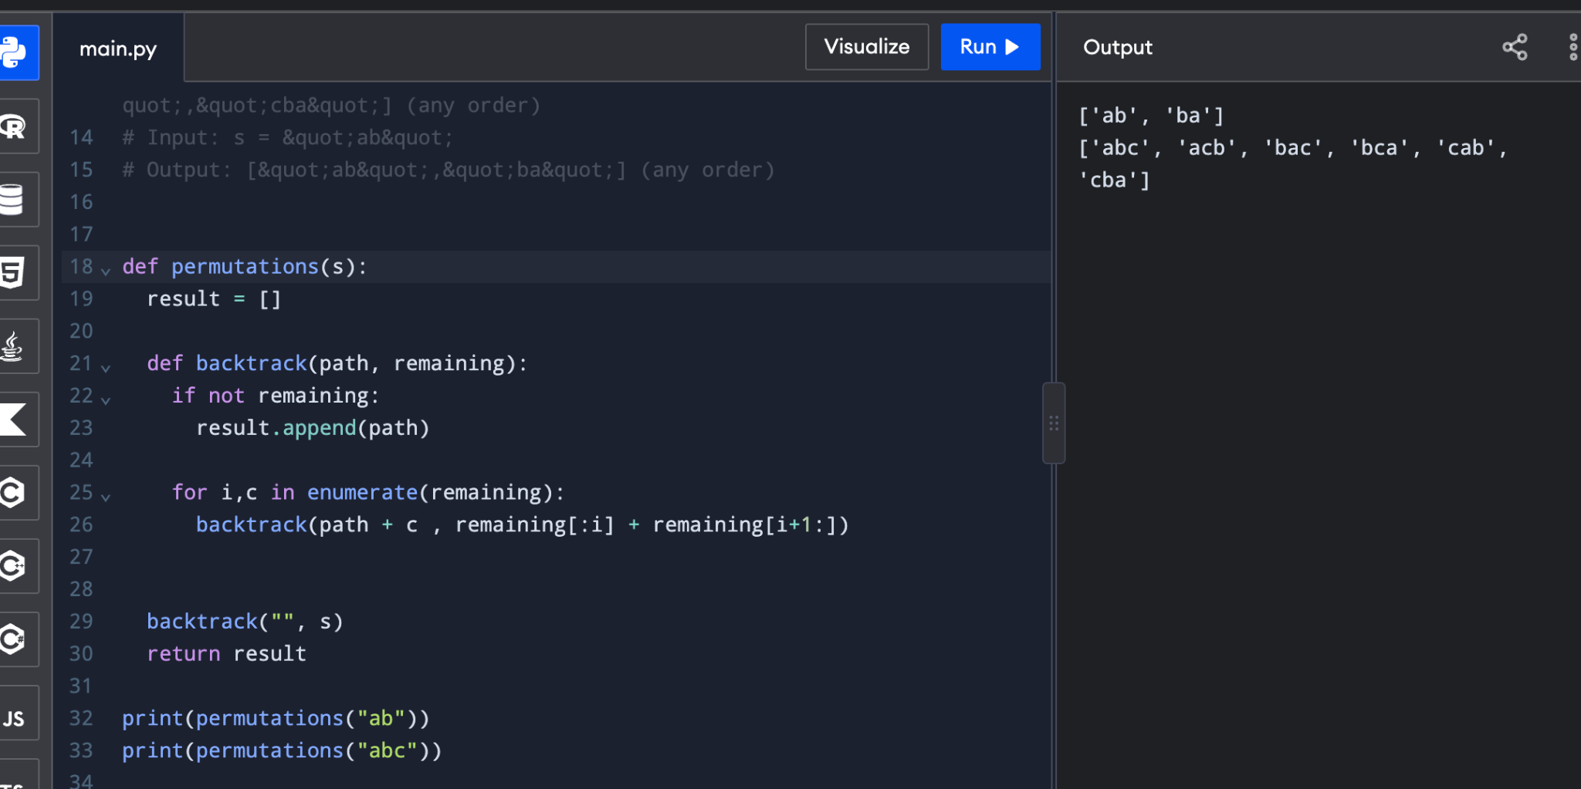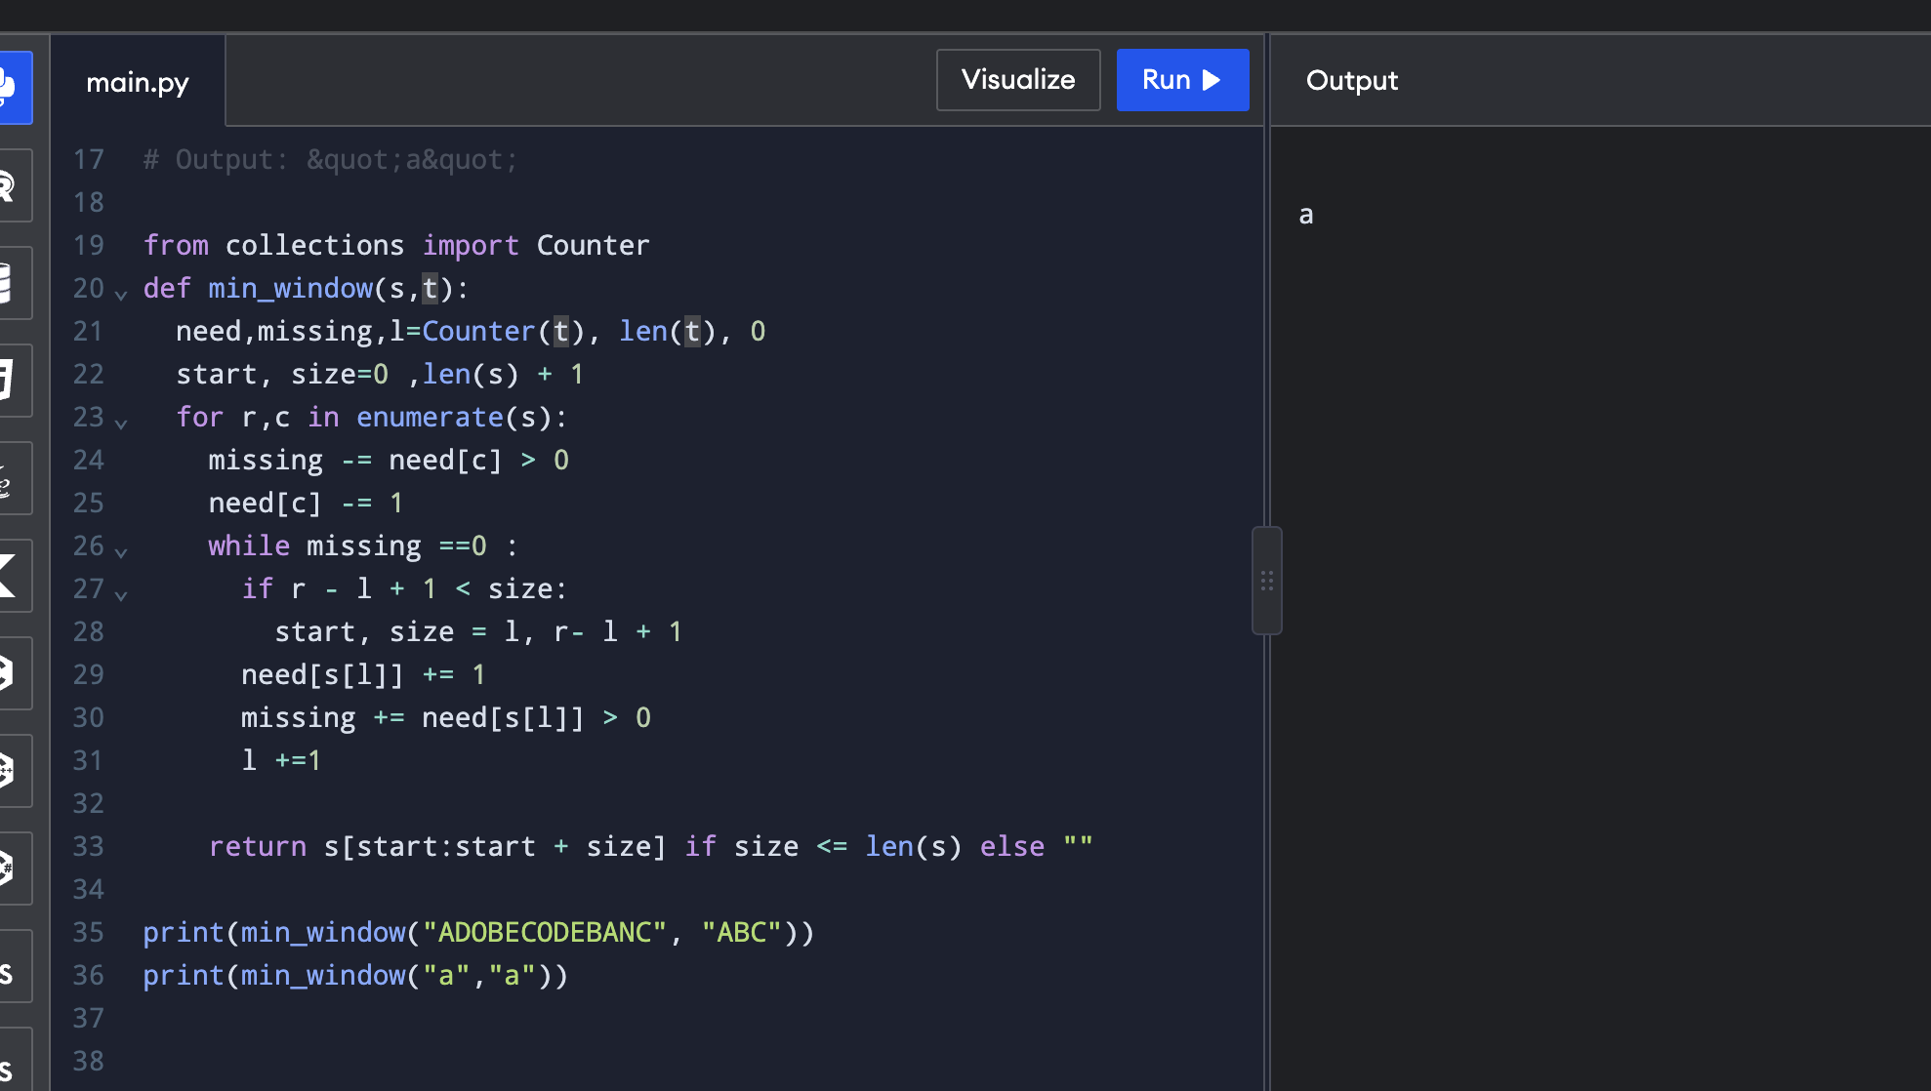
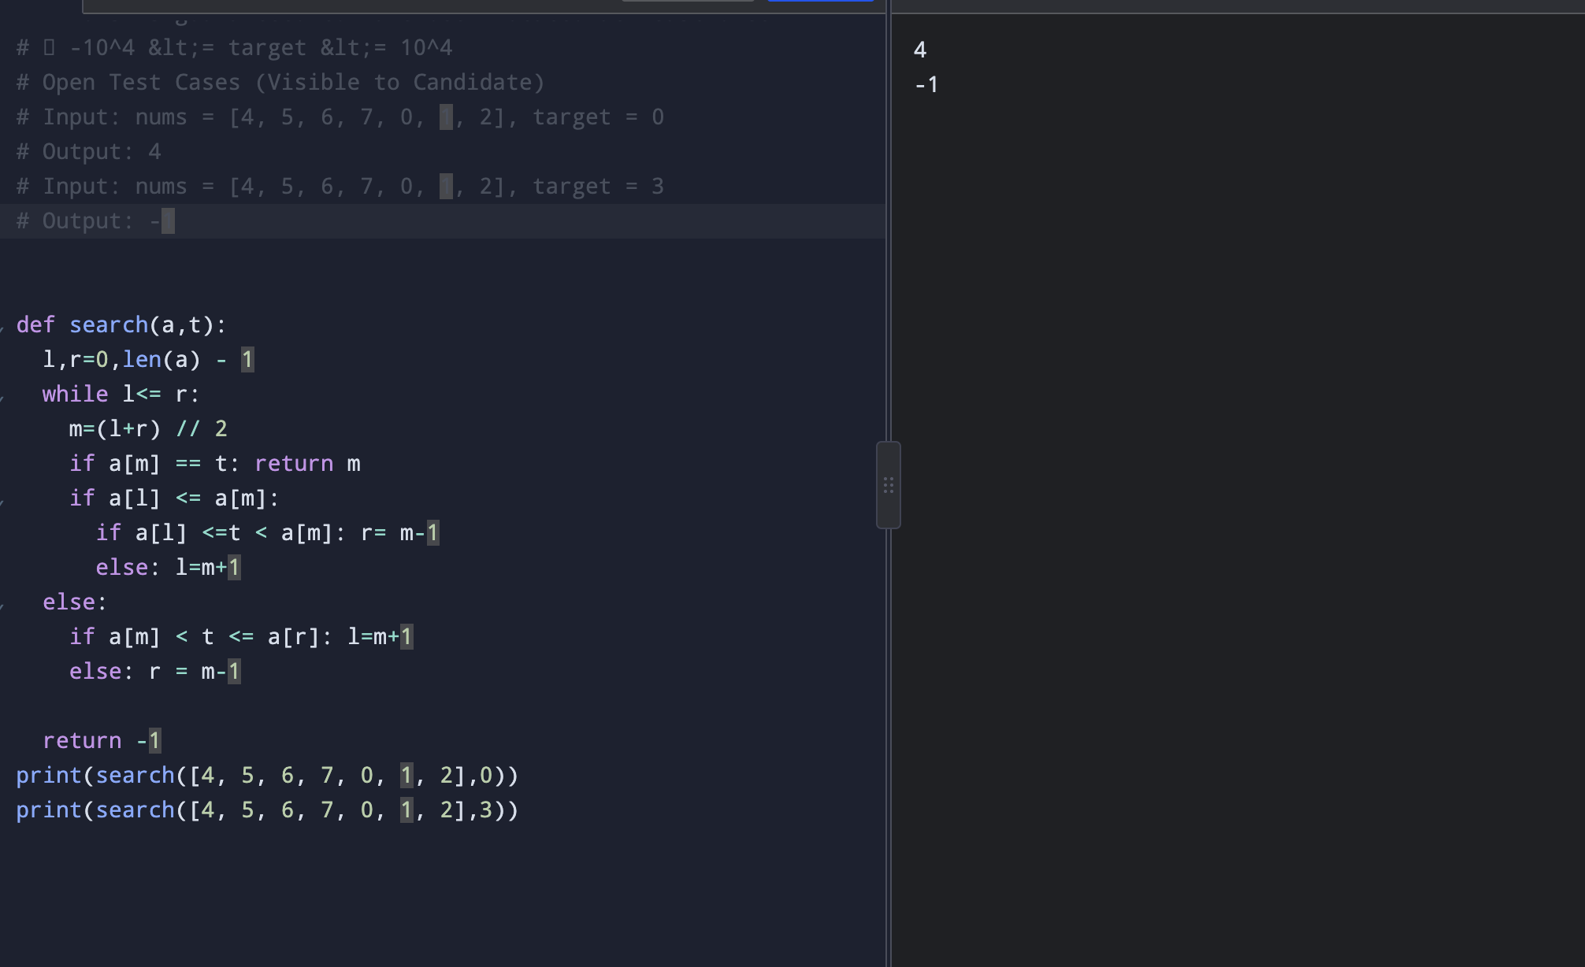

Code 1:
# Coding Q1 - Search in Rotated Sorted Array
# Problem Statement
# You are given an integer array nums that was originally sorted in strictly ascending order but has been
# rotated at some unknown pivot index k. For example, [0, 1, 2, 4, 5, 6, 7] rotated at pivot index 4
# becomes [4, 5, 6, 7, 0, 1, 2].
# Write a function search(nums, target) that returns the index of target in nums, or -1 if target is not
# present.
# Your solution must achieve O(log n) time complexity.

# Constraints
# 1 &lt;= nums.length &lt;= 5000
# -10^4 &lt;= nums[i] &lt;= 10^4
# All values in nums are unique
# nums is guaranteed to have been rotated at least once
# -10^4 &lt;= target &lt;= 10^4
# Open Test Cases (Visible to Candidate)
# Input: nums = [4, 5, 6, 7, 0, 1, 2], target = 0
# Output: 4
# Input: nums = [4, 5, 6, 7, 0, 1, 2], target = 3
# Output: -1

def search(a,t):
l,r=0,len(a) - 1
while l<= r:
m=(l+r) // 2
if a[m] == t: return m
if a[l] <= a[m]:
if a[l] <=t < a[m]: r= m-1
else: l=m+1
else:
if a[m] < t <= a[r]: l=m+1
else: r = m-1

return -1
print(search([4, 5, 6, 7, 0, 1, 2],0))
print(search([4, 5, 6, 7, 0, 1, 2],3))

Code 2:
# Coding Q2 - Minimum Window Substring
# Problem Statement
# Given two strings s and t, return the shortest contiguous substring of s that contains all characters of t
# including duplicates.
# If no such substring exists, return an empty string &quot;&quot;. The answer is guaranteed to be unique when it
# exists.
# Constraints
# 1 &lt;= s.length &lt;= 10^5
# 1 &lt;= t.length &lt;= 10^5
# s and t consist of uppercase and lowercase English letters only
# Expected time complexity: O(|s| + |t|)
# Open Test Cases (Visible to Candidate)
# Input: s = &quot;ADOBECODEBANC&quot;, t = &quot;ABC&quot;
# Output: &quot;BANC&quot;

# Input: s = &quot;a&quot;, t = &quot;a&quot;
# Output: &quot;a&quot;

from collections import Counter
def min_window(s,t):
need,missing,l=Counter(t), len(t), 0
start, size=0 ,len(s) + 1
for r,c in enumerate(s):
missing -= need[c] > 0
need[c] -= 1
while missing ==0 :
if r - l + 1 < size:
start, size = l, r- l + 1
need[s[l]] += 1
missing += need[s[l]] > 0
l +=1

return s[start:start + size] if size <= len(s) else ""

print(min_window("ADOBECODEBANC", "ABC"))
print(min_window("a","a"))

code3:

# Coding Q3 - Generate All Permutations of a String
# Problem Statement
# Given a string s of distinct lowercase characters, return a list of all possible permutations of s.
# You must implement the permutation generation from scratch using backtracking.
# Use of any built-in permutation library functions (e.g., itertools.permutations) is NOT allowed.
# The output list may be returned in any order.
# Constraints
# 1 &lt;= s.length &lt;= 8
# All characters in s are distinct lowercase English letters
# Expected time complexity: O(n × n!)
# Open Test Cases (Visible to Candidate)
# Input: s = &quot;abc&quot;
# Output: [&quot;abc&quot;,&quot;acb&quot;,&quot;bac&quot;,&quot;bca&quot;,&quot;cab&quot;,&quot;cba&quot;] (any order)
# Input: s = &quot;ab&quot;
# Output: [&quot;ab&quot;,&quot;ba&quot;] (any order)

def permutations(s):
result = []

def backtrack(path, remaining):
if not remaining:
result.append(path)

for i,c in enumerate(remaining):
backtrack(path + c , remaining[:i] + remaining[i+1:])

backtrack("", s)
return result

print(permutations("ab"))
print(permutations("abc"))

